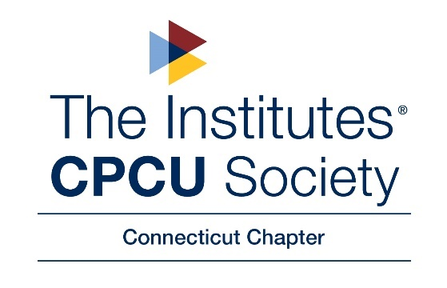

2023 CT CPCU SOCIETY CHAPTER SCHOLARSHIP APPLICATION
Applications must be received by April 21, 2023
*ALL QUESTIONS MUST BE COMPLETED AND SIGNED IN ORDER TO BE CONSIDERED*

Applicant Information:
Full Name:
Mailing Address
(Street, City, Zip):
Phone Number:
Email Address:

I attest to the following:
- I am a child, stepchild, grandchild, sibling, niece/nephew, or am under the legal guardianship of a CT CPCU Society Chapter active member.
  - Member’s Name: ____________________________________________
  - Relationship to Member:________________________________________
- I will be attending or am planning to attend a post high school educational institution.

I certify all information on this application and supporting documentation submitted is true and correct to the best of my knowledge. I understand that any information found to be inaccurate or failure to meet eligibility requirements may result in disqualification of the scholarship or return of the scholarship funds.

Applicant’s Signature

Date Signed

Submit completed application along with all supporting documentation by email or by mail

By Email: deborah.bartucca@iatinsurance.com

CT CPCU Chapter Scholarship Committee
C/O Deborah Bartucca, CPCU
32 Villa Court
Bristol, CT 06010

This first page and all supporting documentation included with the application will be separated from the attached pages once the Scholarship Proctor verifies all documentation. Scholarship committee members will review all validated applicants by the Candidate number assigned below by the Scholarship Proctor.

(FOR SCHOLARSHIP COMMITTEE REVIEW PURPOSES ONLY) Candidate Number: ___________
To be completed by Applicant:

- What recognition(s) have you received in school for academic school excellence e.g. honors, awards, scholarships? Please send available documentation.

- Are you a full-time student enrolled in high school or college? __________________________
If yes, please send a copy of your transcript or other documentation of your grades.

- What are your immediate education plans? Provide a brief summary.

- List any extra-curricular activities in which you have taken part e.g. athletics, clubs, yearbook staff, church, civic, fraternal, recreational, charitable or other organizations in which you have been active during the past two years. Provide details of your role and/or responsibilities.

- What are your vocational plans at this time?

6) Why do you feel you deserve to receive this Scholarship? (Use separate sheet if necessary.)

7) Have you been or are you currently employed? If yes, list your employment history including name of employer, responsibilities and average weekly hours.

8) If you are a full-time college/high school student, what year are you currently completing?
If high school student, at what schools have you applied for admission, been accepted or are now attending?

9) Projected educational costs for the upcoming school year (less reimbursements/awards from other sources (scholarships, etc. - please be specific):

10) The space below may be used to enter any additional data you may wish to bring to the attention of the Scholarship Committee, including recommendations.

ELIGIBILITY

The CT CPCU Society Chapter’s Good Works Committee expects to award one Jerald Alexander (Chapter) scholarship in 2023. This is a $3,000 Scholarship for the immediate family of Chapter Members. It is possible that no award will be made in a given year. The award will not exceed the applicant's educational costs (tuition, fees, books, and study materials).
Eligibility is broad. The applicant must be an immediate family member of a Connecticut CPCU Society Chapter member in good standing with the national society and the local chapter. We define immediate family member as child, stepchild, grandchild, sibling, niece or nephew or person for whom the member is a legal guardian. The applicant must be attending or planning to attend a post-high school educational institution of any nature with no restriction on subject matter.

- Prior recipients of this scholarship are eligible for a second award.
- Non-winning applicants are eligible in subsequent years.
- Multiple family members may apply.

A volunteer panel of local CPCUs reviews the applications on a name-blind basis. The panel considers academics, activities, community service and financial need, and often have favored well-rounded,
high-achieving applicants.

